BLCS Vehicle Checklist

Employee Full Name: _________________ Date: _______________

Please ensure all items are checked and make comments where applicable:
Note: Please be sure to make note of any damages occurred to vehicle

 | Item | Comments
Exterior
☐ | Wipers (Including fluid, wiper blades etc.)
☐ | Lights (Headlights, Signal and Break)
☐ | Windscreen
☐ | Windows
☐ | Door (Front)
☐ | Door (Side)
☐ | Door (Back)
☐ | Body (Front)
☐ | Body (Left)
☐ | Body (Right)
☐ | Body (Back)
☐ | Mirrors
☐ | Tires
☐ | Brakes
☐ | Cleanliness of Exterior
Interior
☐ | Cleanliness (Rubbish, carpet, chairs etc.)
☐ | Air Conditioning
☐ | Seat belts
☐ | Disability Parking Permit
Other
☐ | Petrol (Please note remaining amount in comments eg. FULL, ¾, ½, ¼, EMPTY)
☐ | Wheelchair Lift
☐

Please mark any damaged observed on exterior of van (inclusive of dents, scratches, scuffs, marks etc.):
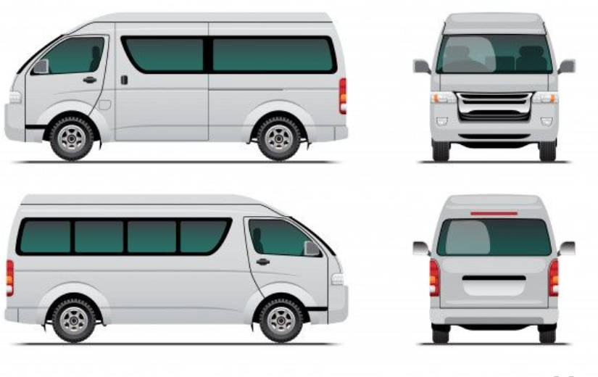
BCLS Van Scratchy

Employee Signature: _________________

